NETWORK TOPOLOGIES

- Draw and label diagrams of star, bus, and mesh network topologies on paper or using any drawing tool. For each, write one real-world app or service (like WhatsApp, Flipkart, or IPL streaming) that could use that topology and explain why in 1-2 lines.
Answer
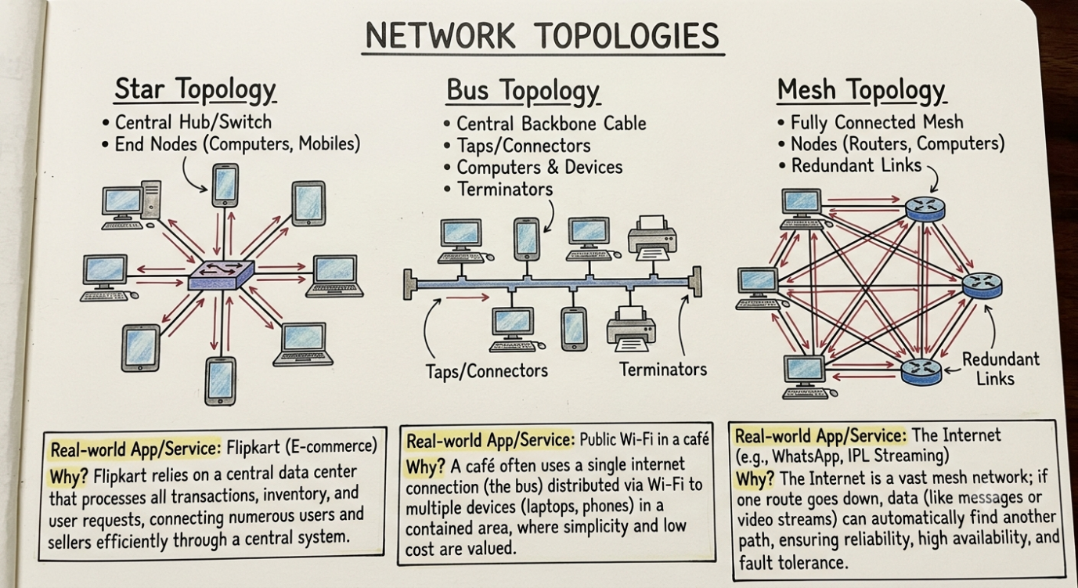

- Create a comparison table listing at least four pros and four cons for each of these topologies: star, bus, ring, mesh. Include a column for 'Best Use Case' and give an example from apps you use (e.g., Instagram, Zomato, Paytm).
Answer
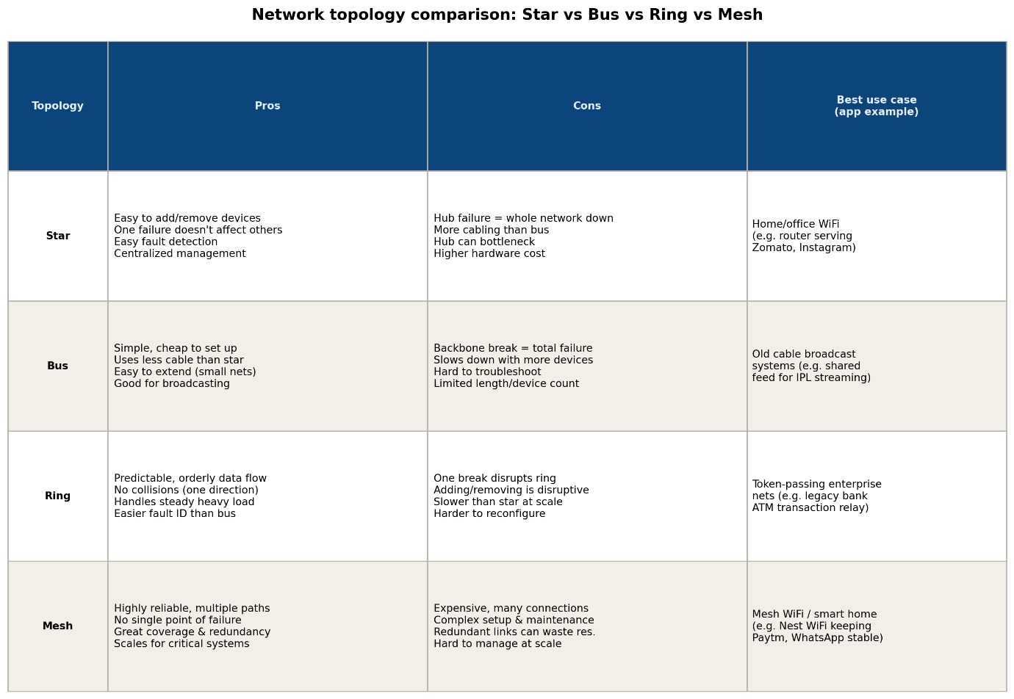

- Imagine you are designing a new multiplayer mobile game like PUBG or Free Fire. Choose a suitable network topology for the game servers and justify your choice in 3-4 lines, mentioning how it would impact speed, reliability, and cost.
Answer
For a multiplayer game like PUBG or Free Fire, a star topology (with players connecting to a central game server, or a set of regional server hubs) is the best fit rather than mesh or peer-to-peer.
- Speed: All players sync through one authoritative server, which keeps game state consistent and reduces the lag and desync issues that peer-to-peer connections would cause with 100 players in a match.
- Reliability: If one player's connection drops, it doesn't affect anyone else — only that player is disconnected, while the match continues for the rest.
- Cost: It's far cheaper and easier to scale than a full mesh (where every player would need to connect to every other player), since you only need to provision and manage central servers, not thousands of direct player-to-player links.

- Given this scenario: A small Flipkart-style warehouse wants to connect 8 computers for order processing and inventory updates. Recommend a network topology, sketch a quick diagram, and explain your reasoning in 2-3 line. Consider factors like cost, ease of troubleshooting, and future expansion.

